

MongoDB Installation:

1. Download MongoDB installer file from below google drive link.

<https://drive.google.com/file/d/19URstJaRt8mu2rZNBtMrEUD59cVAnKc_/view?usp=sharing>

1. Double click on the MongoDB installater file “mongodb-win32-x86_64-2012plus-4.2.5-rc1-signed.msi”
2. Follow the instructions displayed on the installation wizards.

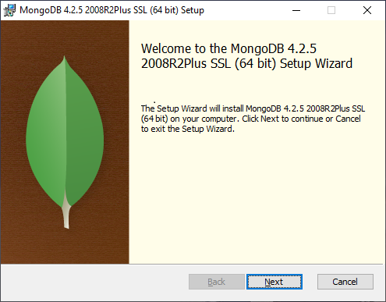

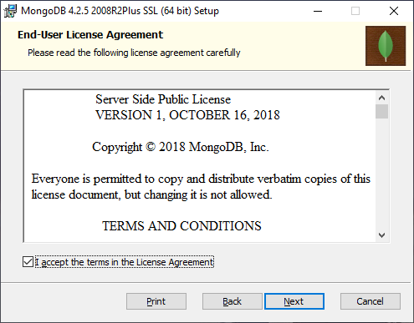

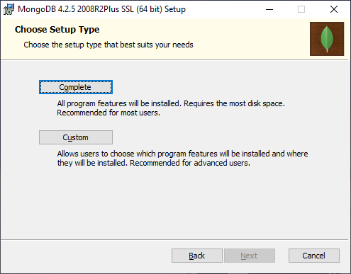

Click on “Complete” button following page will open. Un Select the “Install MongoDB as server” checkbox and then click on “Next” button as shown in the below screenshot.

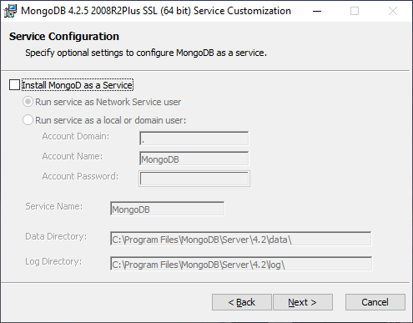

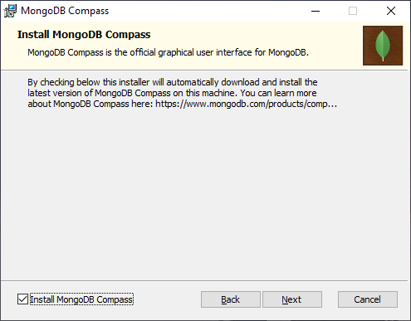

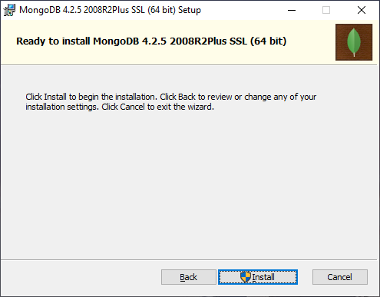

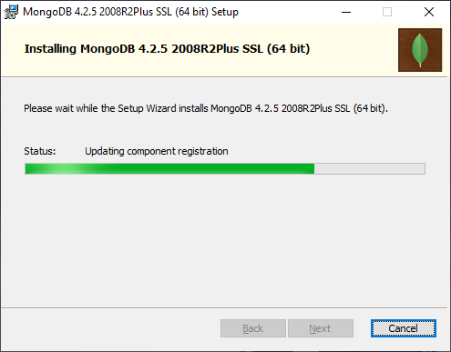

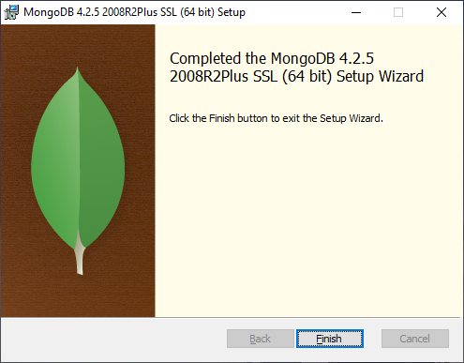

1. Once installation is complete then create folder “C:\\data\db” in the C: drive as shown in the below screen

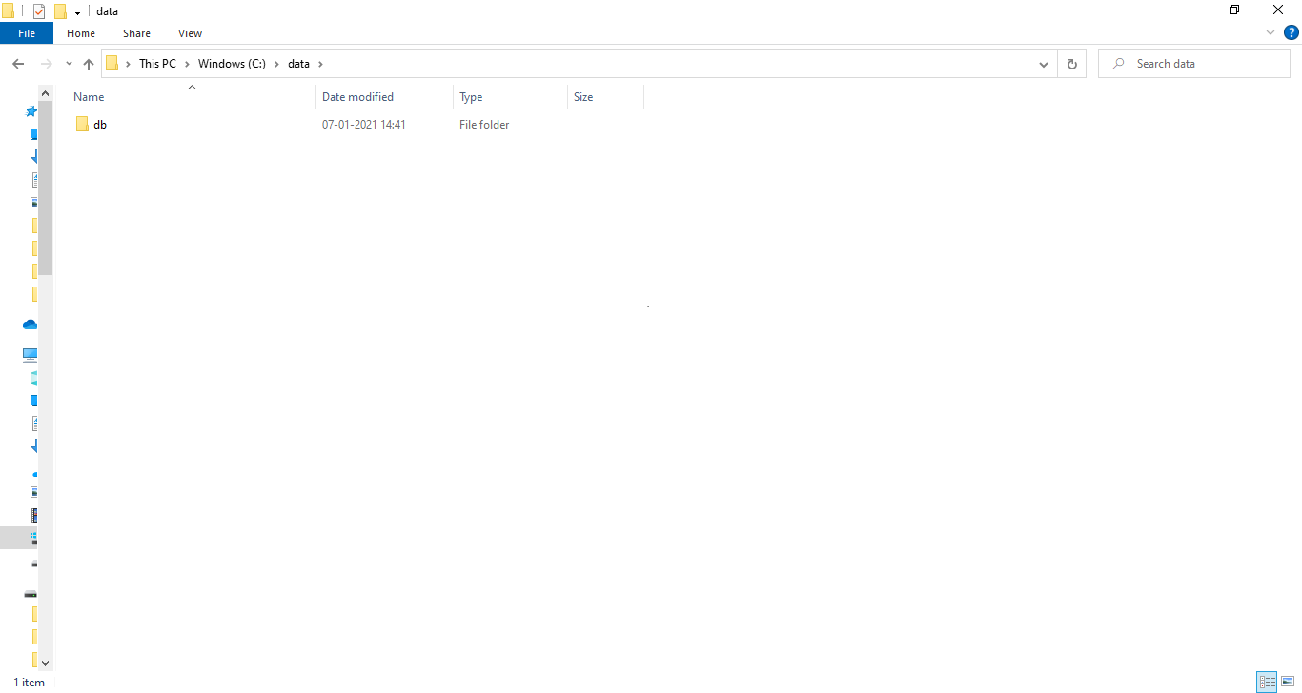

1. To shart MongoDB process, go to “C:\Program Files\MongoDB\Server\4.2\bin” folder and open command prompt by typing “cmd” in explorer as shown in the below screenshot.

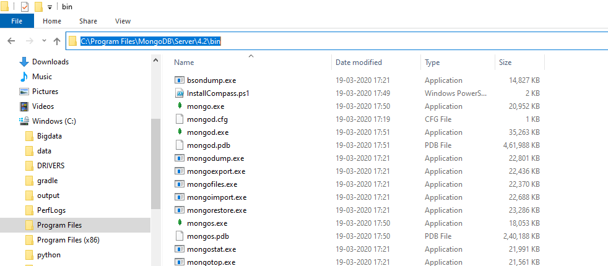

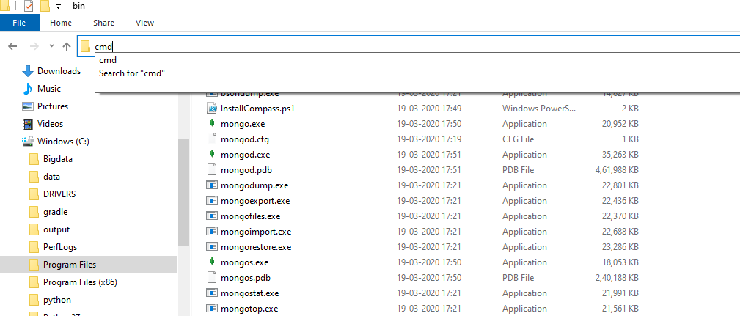

Type “mongod” in the command prompt

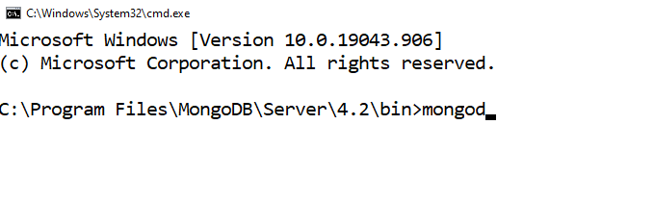

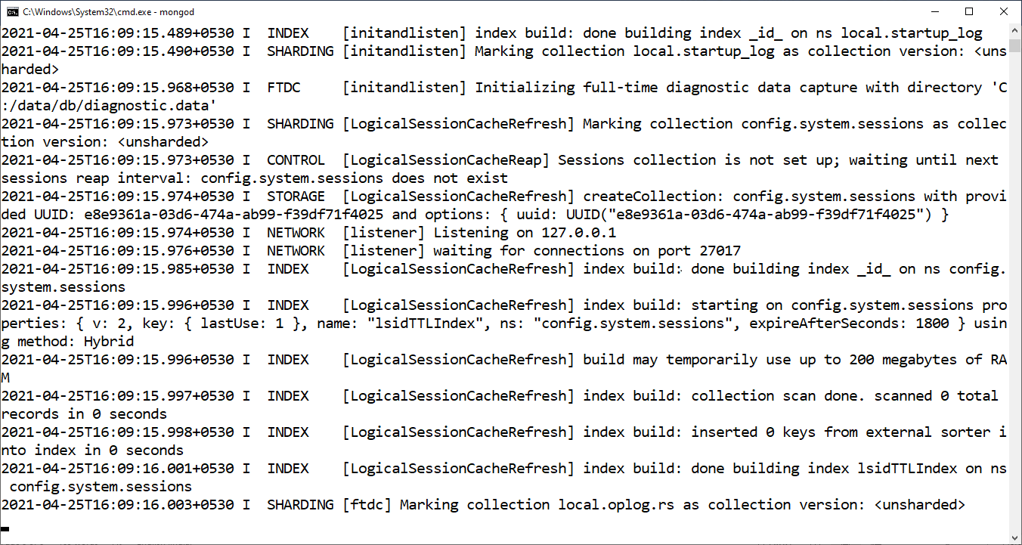

1. To start the “mongo” client tool , type “mongo” in the command prompt as shown in below screenshots.

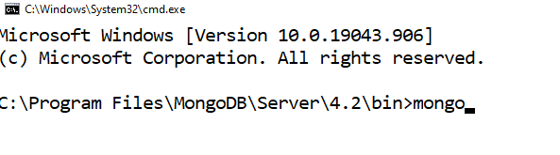

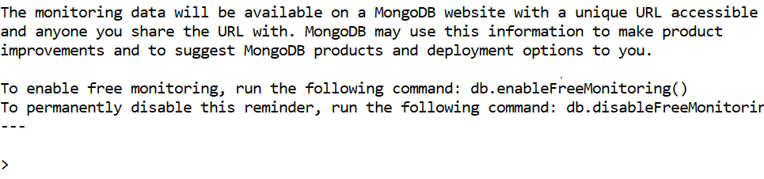

**Working with MongoDB:**

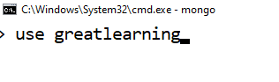

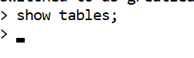

**INSERT:**

Let’s insert some data in a collection(also called as table) in MongoDB.

db.salesdata.insert({"sales_id":1,country:"India","Product_detail" : {"product_id": 100,"Amount": 5000,"Vendor_code":13, "Vendor_description": "this vendor is expert in providing mobile phones"}})

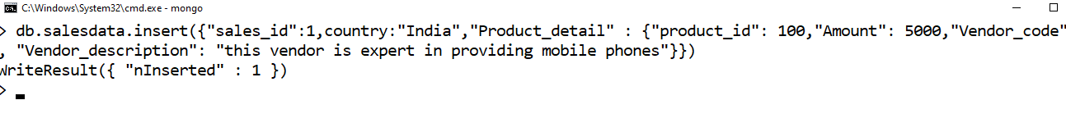

db.salesdata.insert({_id:ObjectId("5955f4bb212e8fb45ca200d7"),"sales_id":2,country:"India","Product_detail" : {"product_id": 101,"Amount": 6000,"Vendor_code":13, "Vendor_description": "this vendor is expert in providing mobile phones"}})

db.salesdata.insert({"sales_id":1,country:"India","Product_detail" : {"product_id": 100,"Amount": 5000,"Vendor_code":13, "Vendor_description": "this vendor is expert in providing mobile phones"}})

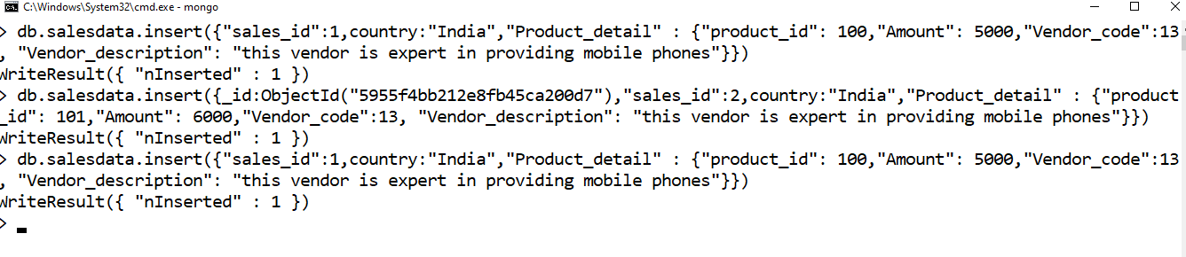

**SELECT or FIND Queries:**

Now, we have some data inserted in the mongodb table so we can go-ahead and execute some find queries

db.salesdata.find({"country": "India"})

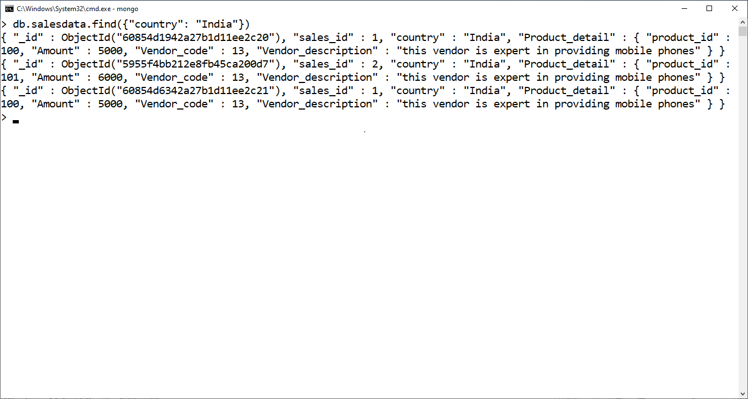

db.salesdata.find({"country": "India", "sales_id":1})

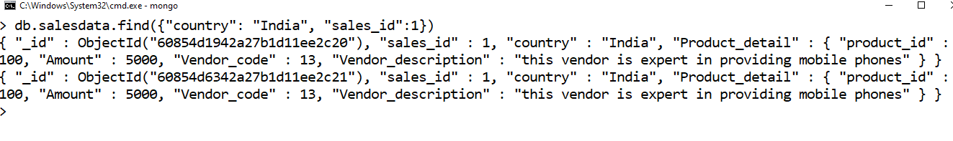

db.salesdata.find({"Product_detail.Vendor_code": 13})

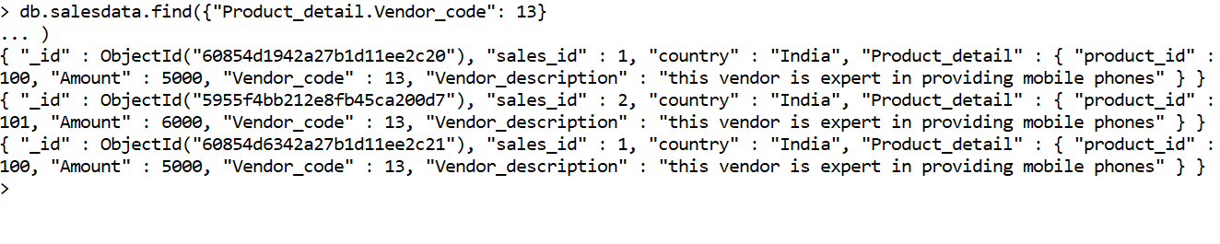

**Creating Index:**

db.salesdata.createIndex({"country":1})

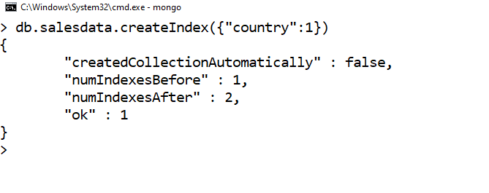

**Composite Index:**

db.salesdata.createIndex({"sales_id": 1,"Product_detail.Vendor_code":1});

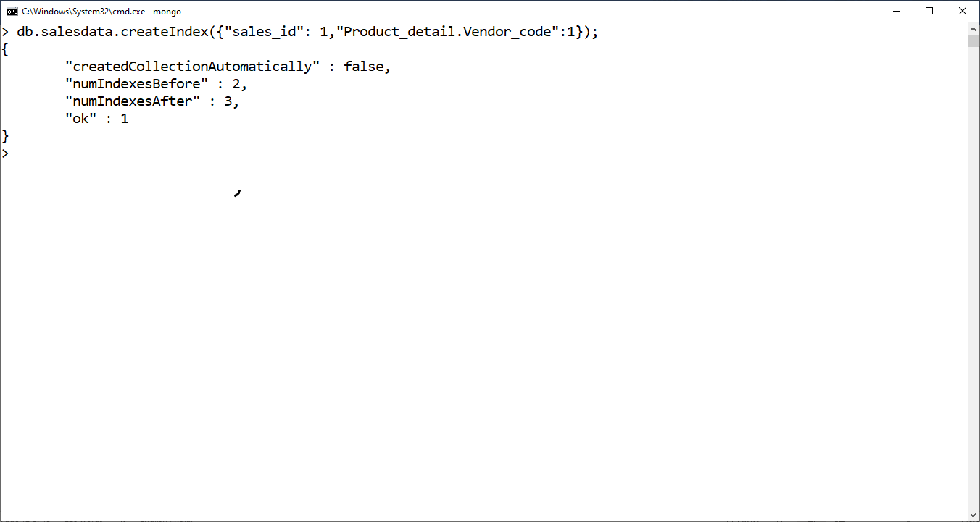

**UPADTE Queries:**

Let update record for sales_id:1 to add customer name and city as nested object.

db.salesdata.update({"sales_id": 1}, {$set : {"customer": {"name":"Suresh","city":"Hyd"}}},{multi: true})



**Delete Queries:**

If we want to remove a record or records or mongodb table then we need to run below command

Let’s say we want to remove record for sales_id: 2 then we need to run below command

db.salesdata.remove({"sales_id":2})

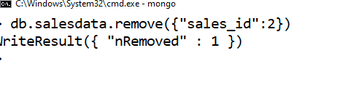

**Building Python application with MongoDB**

1. First install MongoDB python driver by running below command

pip install pymongo

1. Now use Jupyter notebook to write python application. Notebook for same have been provided with this class note as “InClassAssignment”.